**Front End Engineering-II**

Project Report

Semester-IV (Batch-2022)

PROJECT TITLE:

HOTEL AMERICA



**Supervised By: Submitted By:**

Raveesh Samkaria Tamanna (2210990885) G-13

**Department of Computer Science and Engineering**

**Chitkara University Institute of Engineering & Technology,**

**Chitkara University, Punjab**

**Abstract:**

The Front End Website Template for Hotel Management project aims to provide a user-friendly and visually appealing interface tailored for hotel management systems. In an increasingly digital age, the hospitality industry relies heavily on online platforms to engage customers and manage operations efficiently. This project focuses on delivering a customizable website template that caters to the specific needs of hotels, enabling them to showcase their services, manage bookings, and interact with guests seamlessly.

The template emphasizes intuitive navigation and elegant design to enhance the user experience for both guests and hotel staff. For now this project only contains the properties of HTML and CSS. The key features include:

**Responsive Design:**

The template is designed to be responsive across some devices, ensuring accessibility for users browsing from desktops, tablets, and smartphones.

**Visual Gallery:**

High-resolution images and multimedia content showcase the hotel's facilities, rooms, dining options, and nearby attractions, enticing guests to explore and book their stay.

**Interactive Elements:** Interactive elements such as hover effects, animations, and transitions are implemented to enhance user engagement and provide feedback during interactions with the website.

**Customizable Themes and Branding:**

The template offers flexibility in branding and customization, allowing hotels to reflect their unique identity and maintain brand consistency across the website.

**Social Media Integration:**

Integration with social media platforms facilitates seamless sharing of experiences, promotions, and user-generated content, amplifying the hotel's online presence and fostering community engagement.

In conclusion, the Front End Website Template for Hotel Management project provides a comprehensive solution for hotels to establish a compelling online presence, streamline operations, and enhance guest satisfaction. With its user-centric design the template empowers hotels to stay competitive in today's digital landscape while delivering exceptional guest experiences.

**CONTENTS:**

|  |  |  |  |
| --- | --- | --- | --- |
| S. no. | Sections | Page no. | Remarks |
| 1 | Introduction | 4-5 |  |
| 2 | Problem definitions and requirements | 6 |  |
| 3 | Proposed design/Methodology | 7-9 |  |
| 4 | Results | 10-35 |  |
| 5 | References | 36 |  |
|  |  |  |  |
|  |  |  |  |

1. **Introduction:**

In the dynamic landscape of the hospitality industry, establishing a strong online presence is paramount for hotels aiming to thrive in the digital age. The Front End Website Template for Hotel Management project addresses this need by offering a user-friendly and visually captivating interface tailored specifically for hotel management systems. In an era where guests increasingly rely on digital platforms to explore, book, and engage with accommodations, this template provides hotels with a powerful tool to showcase their services, manage bookings efficiently, and interact seamlessly with guests. By prioritizing intuitive navigation, elegant design, and responsive functionality, this template aims to revolutionize the way hotels present themselves online, empowering them to stay competitive and deliver exceptional guest experiences.

* 1. **Background:**

As the hospitality industry evolves in response to technological advancements and shifting consumer preferences, hotels are recognizing the critical importance of their online presence. In an era characterized by digital interaction and instant connectivity, guests expect seamless access to information, effortless booking processes, and engaging experiences from hotel websites. Recognizing these trends, the Front End Website Template for Hotel Management project emerges as a solution to empower hotels in meeting these demands. Leveraging the power of HTML and CSS, this template offers hotels the opportunity to not only showcase their facilities and services but also to create personalized and immersive online experiences for their guests. With the integration of responsive design, visual galleries, customizable themes, and social media connectivity, the template equips hotels with the necessary tools to establish a compelling online presence, streamline operations, and elevate guest satisfaction in today's increasingly digital landscape.

* 1. **Objectives:**

Through the Front End Website Template for Hotel Management project, our primary objectives revolve around empowering hotels to thrive in the digital era by enhancing their online presence and streamlining operational efficiency. By providing a user-friendly interface tailored specifically for hotel management systems, we aim to enable hotels to showcase their services, manage bookings seamlessly, and engage with guests effectively. Our focus on intuitive navigation, elegant design, and responsive functionality underscores our commitment to delivering exceptional user experiences for both guests and hotel staff. With customizable themes, visual galleries, and social media integration, our goal is to offer hotels the flexibility and tools they need to reflect their unique identity, attract guests, and foster community engagement. Ultimately, we envision the Front End Website Template for Hotel Management as a comprehensive solution that empowers hotels to stay competitive, adapt to evolving consumer expectations, and elevate guest satisfaction in the digital landscape.

* 1. **Significance:**

The significance of the Front End Website Template for Hotel Management project lies in its ability to address critical needs within the hospitality industry and empower hotels to thrive in today's digital landscape. In an era where online presence and user experience are paramount, this project offers hotels a powerful tool to establish a compelling online identity, streamline operations, and enhance guest satisfaction. By providing a customizable template that emphasizes intuitive navigation, elegant design, and responsiveness across various devices, hotels can effectively showcase their facilities, manage bookings seamlessly, and engage with guests in a meaningful way. The integration of visual galleries and social media platforms further amplifies hotels' online presence, enabling them to attract potential guests, foster community engagement, and drive revenue growth. As hotels navigate the complexities of the digital age, the Front End Website Template for Hotel Management project emerges as a strategic asset, empowering hotels to stay competitive, adapt to evolving consumer preferences, and deliver exceptional guest experiences.

1. **Problem definition and requirements:**

The hospitality industry faces a pressing need for effective online platforms tailored to hotel management systems, capable of enhancing guest experiences, streamlining operations, and maintaining competitive advantages in the digital landscape. Current solutions often lack the flexibility, customization options, and seamless integration necessary to meet the diverse needs of hotels and their guests. Thus, there is a clear demand for a comprehensive Front End Website Template for Hotel Management that prioritizes intuitive navigation, elegant design, responsive functionality, and seamless integration with social media platforms to empower hotels to establish compelling online identities and drive guest engagement.

* 1. **Software Requirements:**

HTML and CSS development environment (e.g., Sublime Text, Visual Studio Code)

Web development frameworks (e.g., Bootstrap, Foundation)

Image editing software (e.g., Adobe Photoshop, GIMP)

Version control system (e.g., Git)

* 1. **Hardware Requirements:**

Personal computer or laptop with sufficient processing power and memory for web development tasks.

High-resolution display for accurate design visualization.

* 1. **Datasets:**

Hotel information dataset: Includes details such as hotel name, location, facilities, room types, and pricing.

Image dataset: High-resolution images showcasing hotel facilities, rooms, dining options, and nearby attractions.

Social media content dataset: User-generated content, reviews, and promotions related to the hotel industry for integration with social media platforms.

These datasets will enable developers to populate the website template with relevant content, ensuring a rich and immersive user experience for visitors. Additionally, the datasets can be utilized for testing and refining the website template to meet the specific needs and preferences of hotels and their guests.

1. **Proposed Design/Methodology:**
   1. **Schematic Diagram:**

The Front End Website Template for Hotel Management project adopts a modular design approach to ensure flexibility and scalability. The schematic diagram illustrates the architecture of the project, highlighting the key components and their interactions.

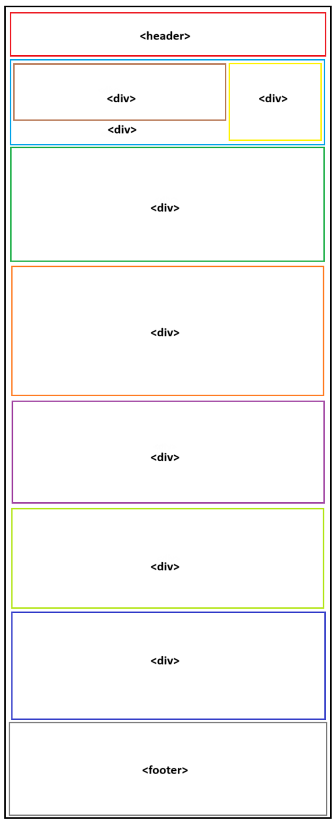

Figure 3.1 - Schematic diagram

* 1. **Template:**

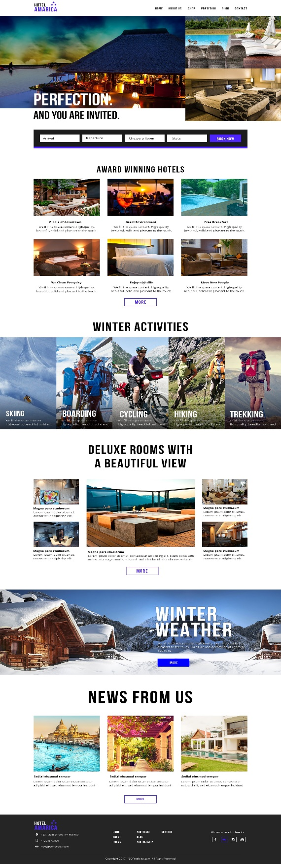

Figure 3.2 - Template

* 1. **File Structure:**

The project is organized into several directories and files to maintain clarity and facilitate efficient development. The file structure includes the following main components:

css/ - Contains cascading style sheets (CSS) files for styling the website.

images/ - Stores high-resolution images showcasing hotel facilities, rooms, dining options, and nearby attractions.

index.html - Main HTML file serving as the homepage of the website.

about.html - HTML file providing information about the hotel and its services.

contact.html - HTML file containing contact details and inquiry forms for guests.

booking.html - HTML file facilitating the booking process for guests.

assets/ - Directory for storing additional assets such as fonts, icons, and multimedia content.

README.md - Markdown file providing documentation and instructions for developers.

The file structure ensures clear organization and separation of concerns, facilitating collaboration among developers and ease of maintenance.

* 1. **Algorithms used:**

The Front End Website Template for Hotel Management project primarily leverages front-end web development technologies such as HTML, CSS, and JavaScript. While these technologies do not involve complex algorithms, certain algorithms may be employed for specific functionalities, such as:

Responsive Design Algorithm: Utilizes CSS media queries to adjust the layout and styling of the website based on the device's screen size and orientation, ensuring optimal viewing experience across desktops, tablets, and smartphones.

Image Optimization Algorithm: Implements techniques such as image compression and lazy loading to optimize the loading speed and performance of high-resolution images, minimizing bandwidth usage and enhancing user experience.

Form Validation Algorithm: Employs JavaScript validation functions to validate user input in inquiry forms and booking forms, ensuring data integrity and accuracy before submission to the server.

These algorithms play a crucial role in enhancing the functionality, performance, and user experience of the website template, contributing to its effectiveness in meeting the needs of hotels and their guests in the digital landscape.

1. **Results:**
   1. **Screenshots:**

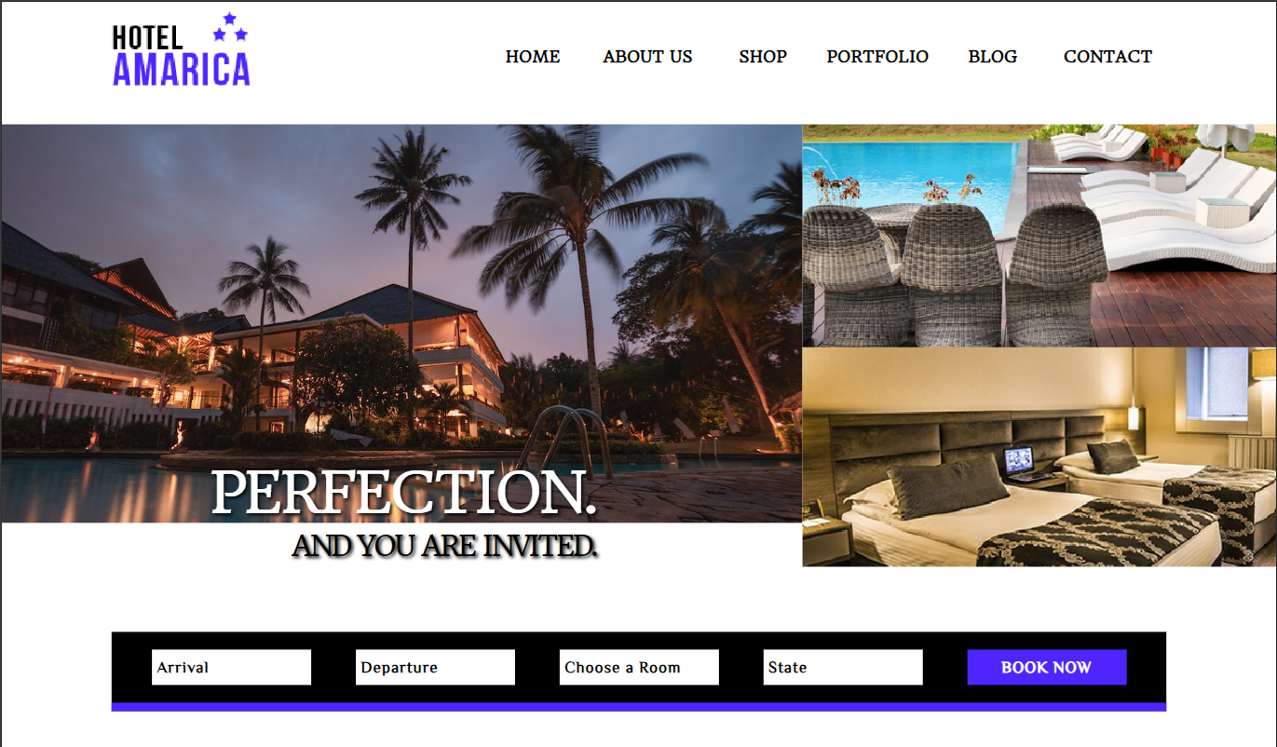

Figure 4.1 - Screenshot 1

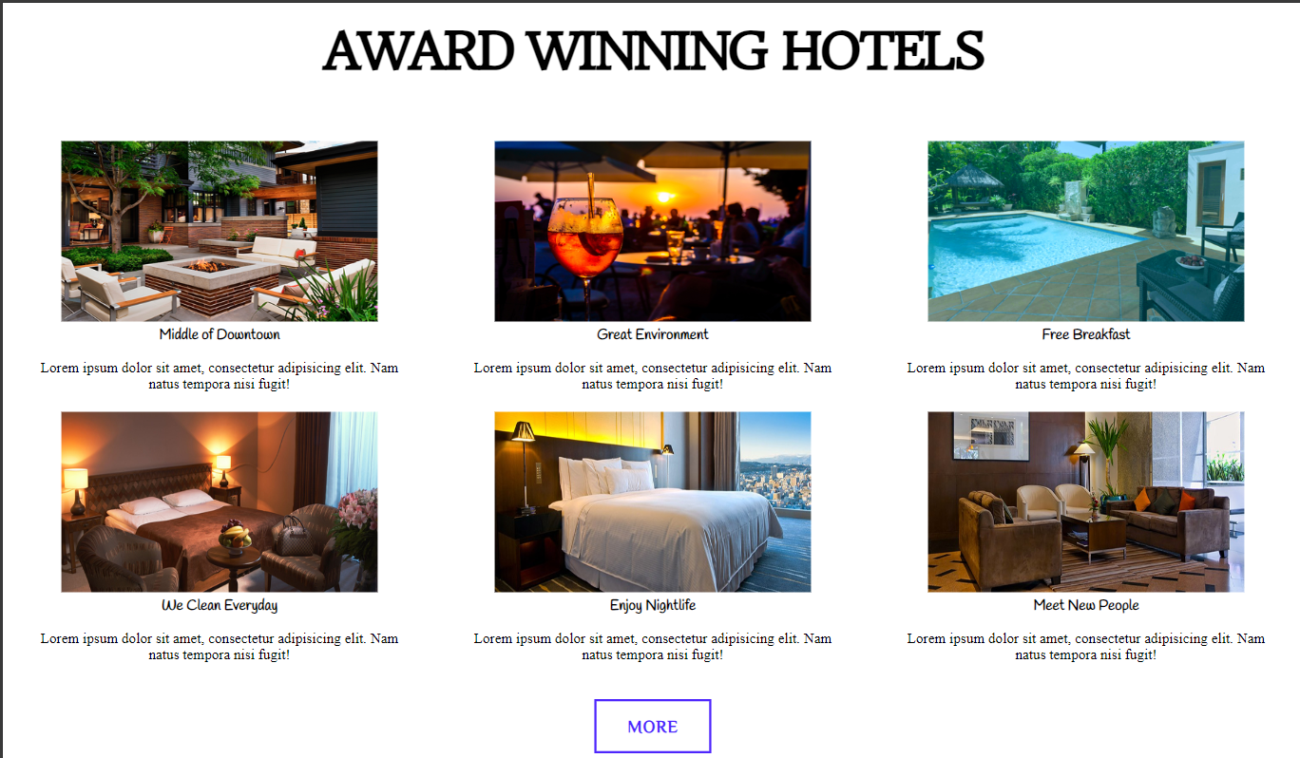

Figure 4.1 - Screenshot 2

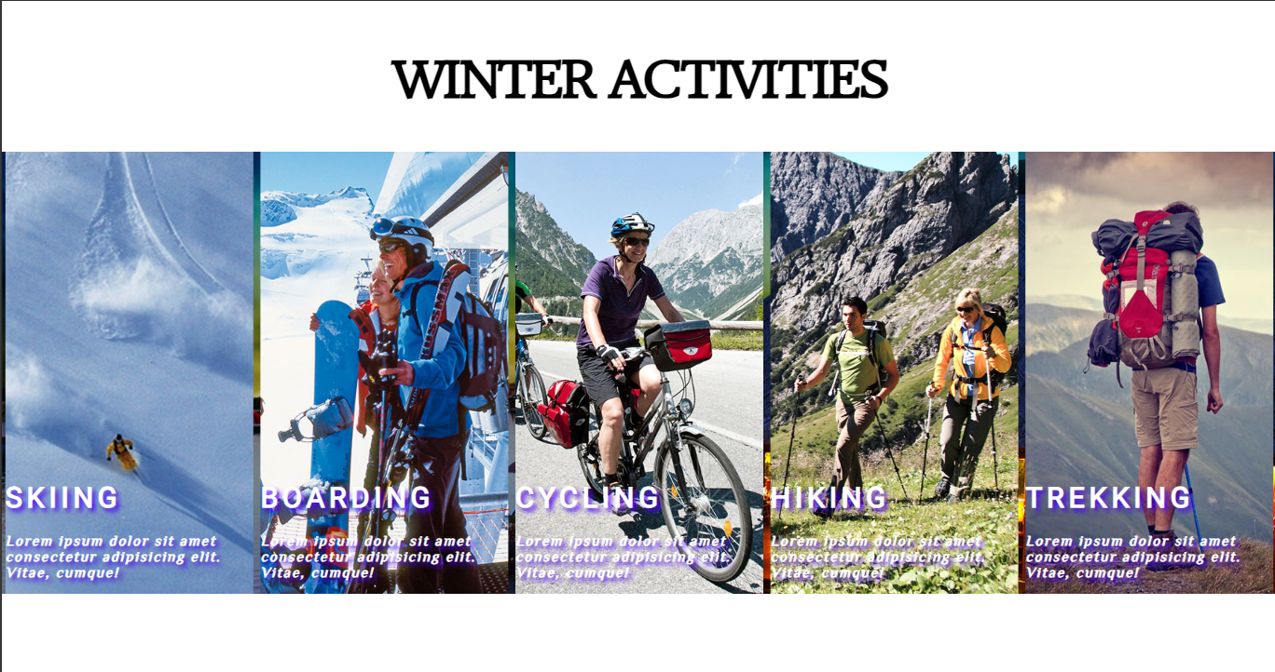

Figure 4.1 - Screenshot 3

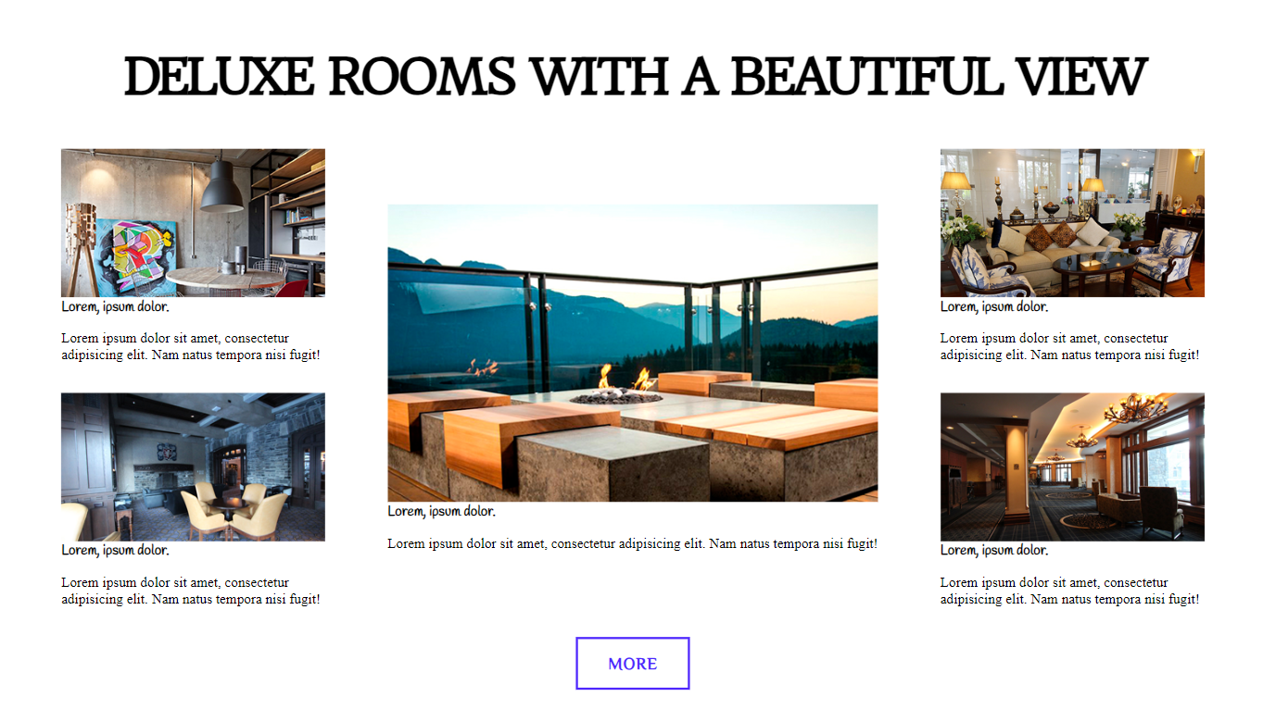

Figure 4.1 - Screenshot 4

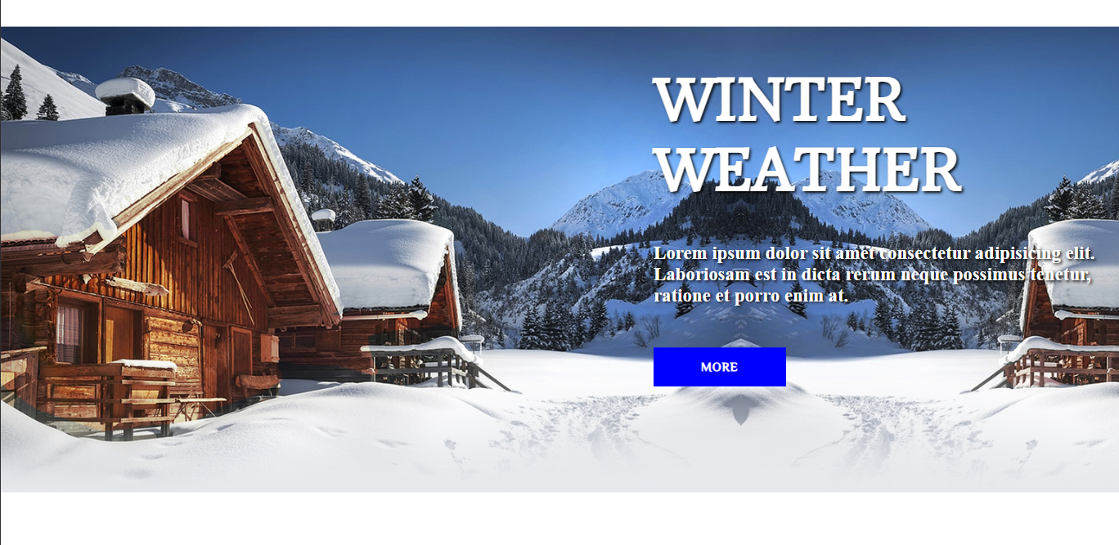

Figure 4.1 - Screenshot 5

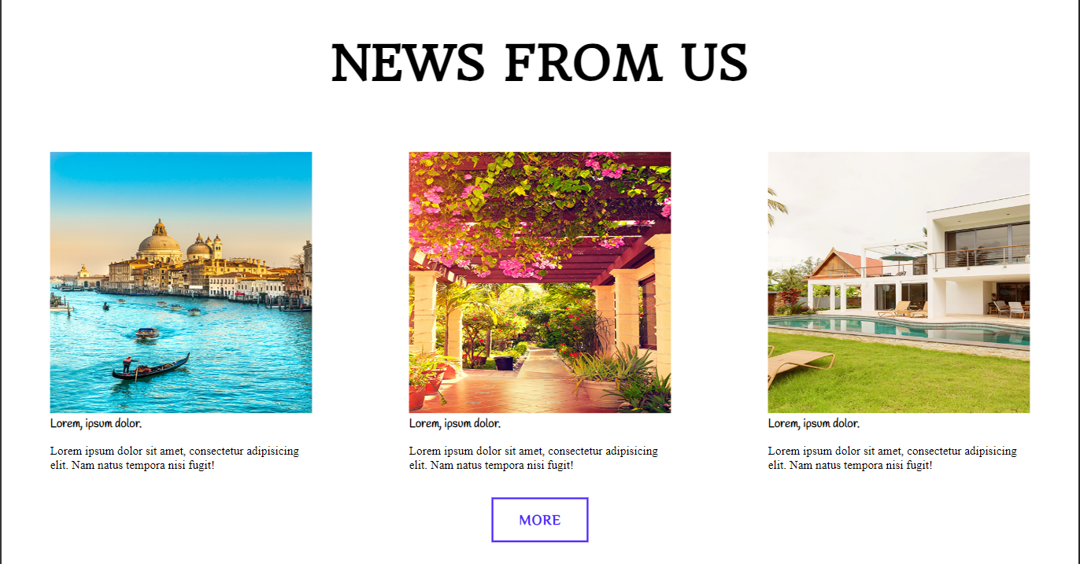

Figure 4.1 - Screenshot 6

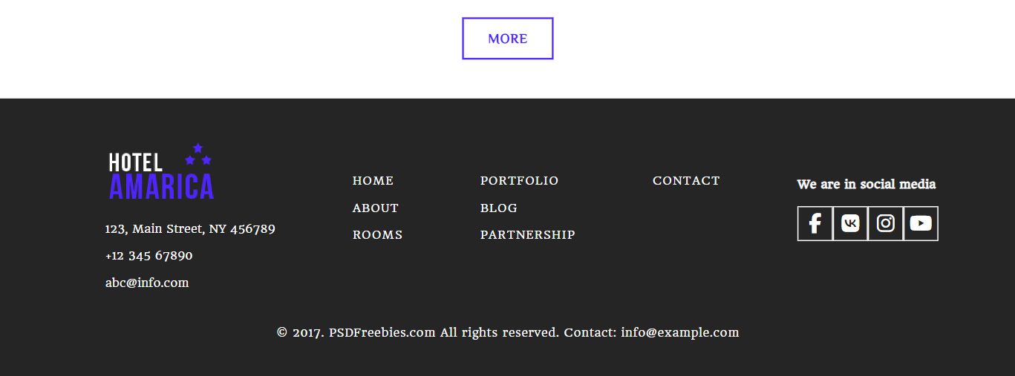

Figure 4.1 - Screenshot 7

* 1. **Metrics:**

In evaluating the performance and effectiveness of the front-end website template, the following metrics were considered:

* Page Load Time: The average page load time for the website across different devices and internet connections.
* Responsiveness: Evaluation of the website's responsiveness across various screen sizes and resolutions.
* User Engagement: Metrics related to user interaction and engagement, such as bounce rate, session duration, and page views.
* Conversion Rate: Analysis of the percentage of website visitors who successfully complete booking inquiries or reservations.
* Social Media Engagement: Metrics measuring the reach, engagement, and conversion rates of social media integration features.
  1. **HTML Code:**

<!DOCTYPE html>

<html lang="en">

<head>

    <meta charset="UTF-8">

    <meta name="viewport" content="width=device-width, initial-scale=1.0">

    <title>Hotel management</title>

    <link rel="stylesheet" href="hotelcss.css">

    <link rel="stylesheet" href="https://cdnjs.cloudflare.com/ajax/libs/font-awesome/6.5.1/css/all.min.css">

    <link rel="stylesheet" href="https://fonts.googleapis.com/css?family=Headland One|Handlee|Philosopher|Roboto">

</head>

<body>

<header>

        <button class="heading" type="button" onclick="window.location.href=''">

        </button>

        <div class="icon">

            <a class="home" onclick="window.location.href=''">HOME</a>

            <a class="about" onclick="window.location.href=''">ABOUT US</a>

            <a class="shop" onclick="window.location.href=''">SHOP</a>

            <a class="portfolio" onclick="window.location.href=''">PORTFOLIO</a>

            <a class="blog" onclick="window.location.href=''">BLOG</a>

            <a class="contact" onclick="window.location.href=''">CONTACT</a>

        </div>

        <div class="bar">

            <i class="fa-solid fa-bars"></i>

        </div>

</header>

<br>

<div class="content1">

    <div class="img1">

        <div class="text3"><p><h style="color: white; font-family:Headland One; font-size:4rem; letter-spacing: -3px;">PERFECTION.</h><br><h style="color: black; font-family:Headland One; font-size:2rem; letter-spacing: -3px;">AND YOU ARE INVITED.</h></p></div>

    </div>

    <div class="img23"></div>

</div>

<br>

<br>

<br>

<br>

<div class="content2">

    <div class="box">

        <div class="box1">

            <button class="arrival" type="button" onclick="window.location.href=''" style="font-family: Philosopher; font-weight: bold; font-size:large; text-align: left; letter-spacing: 1px;">Arrival</button>

            <button class="departure" type="button" onclick="window.location.href=''" style="font-family: Philosopher; font-weight: bold; font-size:large; text-align: left; letter-spacing: 1px;">Departure</button>

            <button class="room" type="button" onclick="window.location.href=''" style="font-family: Philosopher; font-weight: bold; font-size:large; text-align: left; letter-spacing: 1px;">Choose a Room</button>

            <button class="state" type="button" onclick="window.location.href=''" style="font-family: Philosopher; font-weight: bold; font-size:large; text-align: left; letter-spacing: 1px;">State</button>

            <button class="book" type="button" onclick="window.location.href=''" style="font-family: Philosopher; font-weight: bold; font-size:large; text-align:center; letter-spacing: 1px; color:white;">BOOK NOW</button>

        </div>

    </div>

        <br>

        <div class="box2">

            <h2 style="font-size: 3.5rem; letter-spacing: -4px; color:black; font-family: Headland One;">AWARD WINNING HOTELS</h2>

        </div>

        <br>

        <div class="box3">

            <div class="i1">

                <img src="Layer 2.png" width="350px" height="200px" onclick="window.location.href=''" style="cursor: pointer;"><br>

                <h style="font-weight: bold; font-family:Handlee;">Middle of Downtown</h>

                <p>Lorem ipsum dolor sit amet, consectetur adipisicing elit. Nam natus tempora nisi fugit!</p>

            </div>

            <div class="i2">

                <img src="Layer 9.png" width="350px" height="200px" onclick="window.location.href=''" style="cursor: pointer;"><br>

                <h style="font-weight: bold; font-family:Handlee;">Great Environment</h>

                <p>Lorem ipsum dolor sit amet, consectetur adipisicing elit. Nam natus tempora nisi fugit!</p>

            </div>

            <div class="i3">

                <img src="Layer 19.png" width="350px" height="200px" onclick="window.location.href=''" style="cursor: pointer;"><br>

                <h style="font-weight: bold; font-family:Handlee;">Free Breakfast</h>

                <p>Lorem ipsum dolor sit amet, consectetur adipisicing elit. Nam natus tempora nisi fugit!</p>

            </div>

            <div class="i4">

                <img src="Layer 25.png" width="350px" height="200px" onclick="window.location.href=''" style="cursor: pointer;"><br>

                <h style="font-weight: bold; font-family:Handlee;">We Clean Everyday</h>

                <p>Lorem ipsum dolor sit amet, consectetur adipisicing elit. Nam natus tempora nisi fugit!</p>

            </div>

            <div class="i5">

                <img src="Layer 26.png" width="350px" height="200px" onclick="window.location.href=''" style="cursor: pointer;"><br>

                <h style="font-weight: bold; font-family:Handlee;">Enjoy Nightlife</h>

                <p>Lorem ipsum dolor sit amet, consectetur adipisicing elit. Nam natus tempora nisi fugit!</p>

            </div>

            <div class="i6">

                <img src="Layer 27.png" width="350px" height="200px" onclick="window.location.href=''" style="cursor: pointer;"><br>

                <h style="font-weight: bold; font-family:Handlee;">Meet New People</h>

                <p>Lorem ipsum dolor sit amet, consectetur adipisicing elit. Nam natus tempora nisi fugit!</p>

            </div>

        </div>

        <br>

        <div class="morebutton">

            <button class="more" type="button" onclick="window.location.href=''" style="font-family:Philosopher; letter-spacing: 1px; font-weight: bolder; color: #4e26fd; text-align:center; font-size:1.2rem;">MORE</button>

        </div>

</div>

<br>

<br>

    <div class="content12">

        <div class="box2">

            <h2 style="font-size: 3.5rem; letter-spacing: -4px; color:black; font-family: Headland One;">WINTER ACTIVITIES</h2>

        </div>

            <div class="images1">

                <div class="text" style="background-image: url('Layer 21.png');">

                    <div class="paratext">

                        <p>

                                <h1 class="parahead">SKIING</h1>

                                <i>Lorem ipsum dolor sit amet consectetur adipisicing elit. Vitae, cumque!</i>

                        </p>

                    </div>

                </div>

                <div class="text" style="background-image: url('Layer 22.png');">

                    <div class="paratext">

                        <p>

                            <h1 class="parahead">BOARDING</h1>

                            <i>Lorem ipsum dolor sit amet consectetur adipisicing elit. Vitae, cumque!</i>

                        </p>

                    </div>

                </div>

                <div class="text" style="background-image: url('Layer 23.png');">

                    <div class="paratext">

                        <p>

                            <h1 class="parahead">CYCLING</h1>

                            <i>Lorem ipsum dolor sit amet consectetur adipisicing elit. Vitae, cumque!</i>

                        </p>

                    </div>

                </div>

                <div class="text" style="background-image: url('Layer 20.png');">

                    <div class="paratext">

                        <p>

                            <h1 class="parahead">HIKING</h1>

                            <i>Lorem ipsum dolor sit amet consectetur adipisicing elit. Vitae, cumque!</i>

                        </p>

                    </div>

                </div>

                <div class="text" style="background-image: url('Layer 24.png');">

                    <div class="paratext">

                        <p>

                            <h1 class="parahead">TREKKING</h1>

                            <i>Lorem ipsum dolor sit amet consectetur adipisicing elit. Vitae, cumque!</i>

                        </p>

                    </div>

                </div>

            </div>

    </div>

<br>

<br>

<br>

<br>

<div class="content21">

    <div class="box2">

        <h2 style="font-size: 3.5rem; letter-spacing: -4px; color:black; font-family: Headland One;">DELUXE ROOMS WITH A BEAUTIFUL VIEW</h2>

    </div>

</div>

        <div class="box6">

        <div class="rowi1">

            <div class="i7">

                <div class="i1img" onclick="window.location.href=''" style="background-image: url('Layer 4.png');"></div>

                <div class="i1text">

                    <h style="font-weight: bold; font-family:Handlee;">Lorem, ipsum dolor.</h>

                    <p>Lorem ipsum dolor sit amet, consectetur adipisicing elit. Nam natus tempora nisi fugit!</p>

                </div>

            </div>

            <br>

            <div class="i8">

                <div class="i1img" onclick="window.location.href=''" style="background-image: url('Layer 17.png');"></div>

                <div class="i1text">

                    <h style="font-weight: bold; font-family:Handlee;">Lorem, ipsum dolor.</h>

                    <p>Lorem ipsum dolor sit amet, consectetur adipisicing elit. Nam natus tempora nisi fugit!</p>

                </div>

            </div>

        </div>

            <div class="rowi3">

                <div class="i11">

                    <div class="i1img2" onclick="window.location.href=''" style="background-image: url('Layer 3.png');"></div>

                    <div class="i1text2">

                        <h style="font-weight: bold; font-family:Handlee;">Lorem, ipsum dolor.</h>

                        <p>Lorem ipsum dolor sit amet, consectetur adipisicing elit. Nam natus tempora nisi fugit!</p>

                    </div>

                </div>

            </div>

        <div class="rowi2">

            <div class="i9">

                <div class="i1img" onclick="window.location.href=''" style="background-image: url('Layer 15.png');"></div>

                <div class="i1text">

                    <h style="font-weight: bold; font-family:Handlee;">Lorem, ipsum dolor.</h>

                    <p>Lorem ipsum dolor sit amet, consectetur adipisicing elit. Nam natus tempora nisi fugit!</p>

                </div>

            </div>

            <br>

            <div class="i10">

                <div class="i1img" onclick="window.location.href=''" style="background-image: url('Layer 18.png');"></div>

                <div class="i1text">

                    <h style="font-weight: bold; font-family:Handlee;">Lorem, ipsum dolor.</h>

                    <p>Lorem ipsum dolor sit amet, consectetur adipisicing elit. Nam natus tempora nisi fugit!</p>

                </div>

            </div>

        </div>

        </div>

        <br>

        <div class="morebutton">

            <button class="more" type="button" onclick="window.location.href=''" style="font-family:Philosopher; letter-spacing: 1px; font-weight: bolder; color: #4e26fd; text-align:center; font-size:1.2rem;">MORE</button>

        </div>

<br>

<br>

<br>

<div class="content123">

        <div class="text2">

            <h1 style="font-size:450%; text-align:left;font-family:Headland One;">WINTER<br>WEATHER</h1>

            <p style="font-size:150%; text-align:left;  font-family:serif;">Lorem ipsum dolor sit amet consectetur adipisicing elit. Laboriosam est in dicta rerum neque possimus tenetur, ratione et porro enim at.

                <br>

                <br>

                <br>

            <button class="more1" type="button" onclick="window.location.href=''" style="font-family:Philosopher; font-weight: bold; color: white; text-align:center; letter-spacing: 1px; font-size: 1rem;">MORE</button>

            </p>

        </div>

</div>

<br>

<br>

<br>

<div class="content22">

    <h1 style="font-family:Headland One; text-align: center; font-size: 4rem;">NEWS FROM US</h1>

    <br>

    <br>

        <div class="box7">

            <div class="i12">

                <img src="Layer 28.png" width="350px" height="350px" onclick="window.location.href=''" style="cursor: pointer;"><br>

                <h style="font-weight: bold; font-family:Handlee;">Lorem, ipsum dolor.</h>

                <p>Lorem ipsum dolor sit amet, consectetur adipisicing elit. Nam natus tempora nisi fugit!</p>

            </div>

            <div class="i13">

                <img src="Layer 29.png" width="350px" height="350px" onclick="window.location.href=''" style="cursor: pointer;"><br>

                <h style="font-weight: bold; font-family:Handlee;">Lorem, ipsum dolor.</h>

                <p>Lorem ipsum dolor sit amet, consectetur adipisicing elit. Nam natus tempora nisi fugit!</p>

            </div>

            <div class="i14">

                <img src="Layer 30.png" width="350px" height="350px" onclick="window.location.href=''" style="cursor: pointer;"><br>

                <h style="font-weight: bold; font-family:Handlee;">Lorem, ipsum dolor.</h>

                <p>Lorem ipsum dolor sit amet, consectetur adipisicing elit. Nam natus tempora nisi fugit!</p>

            </div>

        </div>

        <br>

        <div class="morebutton">

            <button class="more" type="button" onclick="window.location.href=''" style="font-family:Philosopher; letter-spacing: 1px; font-weight: bolder; color: #4e26fd; text-align:center; font-size:1.2rem;">MORE</button>

        </div>

</div>

<br>

<br>

<br>

<footer>

    <div class="foot1">

        <div class="row1">

            <ul style="color:transparent">

                <li>

            <button class="footh" type="button" onclick="window.location.href=''"></button>

            <br>

            </li>

                <li>

                    <a style="color:white; text-decoration: none; font-size: 1rem; font-family:Headland One;">123, Main Street, NY 456789</a>

                </li><br>

                <li>

                    <a style="color:white; text-decoration: none; font-size: 1rem; font-family:Headland One;">+12 345 67890</a>

                </li><br>

                <li>

                    <a style="color:white; text-decoration: none; font-size: 1rem; font-family:Headland One;">abc@info.com</a>

                </li><br>

            </ul>

            </div>

            <div class="row2">

            <ul style="color:transparent">

                <li>

                    <a href="" style="color:white; text-decoration: none; font-size: 1rem; font-family:Headland One; letter-spacing: 1px;"><h class="footerli">HOME</h></a>

                </li><br>

                <li>

                    <a href="" style="color:white; text-decoration: none; font-size: 1rem; font-family:Headland One; letter-spacing: 1px;"><h class="footerli">ABOUT</h></a>

                </li><br>

                <li>

                    <a href="" style="color:white; text-decoration: none; font-size: 1rem; font-family:Headland One; letter-spacing: 1px;"><h class="footerli">ROOMS</h></a>

                </li><br>

            </ul>

            </div>

            <div class="row3">

            <ul style="color:transparent">

                <li>

                    <a href="" style="color:white; text-decoration: none; font-size: 1rem; font-family:Headland One; letter-spacing: 1px;"><h class="footerli">PORTFOLIO</h></a>

                </li><br>

                <li>

                    <a href="" style="color:white; text-decoration: none; font-size: 1rem; font-family:Headland One; letter-spacing: 1px;"><h class="footerli">BLOG</h></a>

                </li><br>

                <li>

                    <a href="" style="color:white; text-decoration: none; font-size: 1rem; font-family:Headland One; letter-spacing: 1px;"><h class="footerli">PARTNERSHIP</h></a>

                </li><br>

            </ul>

            </div>

            <div class="row4">

            <ul style="color:transparent">

                <li>

                    <a href="" style="color:white; text-decoration: none; font-size: 1rem; font-family:Headland One; letter-spacing: 1px;"><h class="footerli">CONTACT</h></a>

                </li><br>

            </ul>

        </div>

        <div class="row5">

            <ul style="color:transparent">

                <li><h4 style="color:white; font-size: 1rem; font-family:Headland One;letter-spacing: 0.2px;">We are in social media</h4></li>

                <li><div class="social">

                    <button class="logo1" onclick="window.location.href=''" type="logo" title="Facebook">

                        <i class="fa-brands fa-facebook-f"></i>

                    </button>

                    <button class="logo2" onclick="window.location.href=''" type="logo" title="Vk">

                        <i class="fa-brands fa-vk"></i>

                    </button>

                    <button class="logo3" onclick="window.location.href=''" type="logo" title="Instagram">

                        <i class="fa-brands fa-instagram"></i>

                    </button>

                    <button class="logo4" onclick="window.location.href=''" type="logo" title="Youtube">

                        <i class="fa-brands fa-youtube"></i>

                    </button>

                </div></li>

            </ul>

        </div>

    </div>

    <div class="foot2">

        <p style="color:white; align-items: center; letter-spacing: 0.5px; font-family:Headland One;">&copy; 2017. PSDFreebies.com All rights reserved. Contact: info@example.com</p>

    </div>

</footer>

</body>

</html>

* 1. **CSS Code:**

1. body{
2. margin:0px;
3. padding:0;
4. box-sizing: border-box;
5. }
6. @media (max-width:500px) {
7. .icon, .home, .about, .shop, .portfolio, .blog, .contact{
8. display:none;
9. }
11. .bar{
12. display:block;
13. /* border: 2px solid black; */
14. }
15. }
16. .bar{
17. font-size: 1.5rem;
18. cursor: pointer;
19. color:black;
20. display:none;
21. }
22. header{
23. /* border: 3px solid red; */
24. height:auto;
25. display:flex;
26. flex-wrap: wrap;
27. justify-content:space-around;
28. align-items: center;
29. }
30. .heading{
31. /* border:2px solid black; */
32. background-image: url('logo.png');
33. background-size: cover;
34. background-position: center;
35. border:transparent;
36. width:160px;
37. height:120px;
38. cursor: pointer;
39. display:flex;
40. }
41. .heading:hover{
42. border: transparent;
43. }
44. .icon{
45. height:auto;
46. width:auto;
47. align-items: center;
48. display: flex;
49. flex-wrap: wrap;
50. justify-content:space-around;
51. /* border:2px solid black; */
52. }
53. .home, .about, .shop, .portfolio, .blog,.contact{
54. /* border:2px solid black; */
55. background: transparent;
56. border:transparent;
57. height:20px;
58. width:130px;
59. text-align: center;
60. cursor: pointer;
61. font-family:Headland One;
62. font-weight:bold;
63. font-size:large;
64. }
65. .home:hover, .about:hover, .shop:hover, .portfolio:hover, .blog:hover, .contact:hover{
66. color: #4e26fd;
67. }
69. .content1{
70. /* border:5px solid black; */
71. height:auto;
72. display:flex;
73. justify-content: center;
75. }
76. .img1{
77. /* border:2px solid rgb(34, 0, 255); */
78. width:120vh;
79. height:450px;
80. background-image: url('https://images.pexels.com/photos/258154/pexels-photo-258154.jpeg?auto=compress&cs=tinysrgb&w=1260&h=750&dpr=1');
81. background-size: cover;
82. background-position: center;
83. display:flex;
84. align-items: flex-end;
85. justify-content:center;
86. }
87. .text3{
88. /* border: 2px solid rgb(249, 255, 78); */
89. height:90px;
90. width:auto;
91. text-shadow: 2px 2px 4px rgb(0, 0, 0);
92. text-align: end;
93. }
94. .img23{
95. /* border:2px solid rgb(0, 255, 17); */
96. height:500px;
97. width:600px;
98. background-image: url('image1.png');
99. background-size: cover;
100. background-position: center;
101. }
103. .content2{
104. /* border:2px solid black; */
105. display:block;
106. justify-content: center;
107. }
109. .box{
110. /* border:2px solid blue; */
111. width:auto;
112. height:auto;
113. display:flex;
114. justify-content: center;
115. align-items: center;
116. }
117. .box1{
118. border-bottom: 10px solid #4e26fd;
119. padding:20px;
120. width:80%;
121. background-color: black;
122. /* border:2px solid red; */
123. display:flex;
124. flex-wrap: wrap;
125. align-items: center;
126. justify-content:space-around;
127. }
128. .arrival{
129. background: white;
130. border:none;
131. height:40px;
132. width:180px;
133. cursor: pointer;
134. }
135. .arrival:hover{
136. border:2px solid #4e26fd;
137. }
138. .departure{
139. background: white;
140. border:none;
141. height:40px;
142. width:180px;
143. cursor: pointer;
144. }
145. .departure:hover{
146. border:2px solid #4e26fd;
147. }
148. .room{
149. background: white;
150. border:none;
151. height:40px;
152. width:180px;
153. cursor: pointer;
154. }
155. .room:hover{
156. border:2px solid #4e26fd;
157. }
158. .state{
159. background: white;
160. border:none;
161. height:40px;
162. width:180px;
163. cursor: pointer;
164. }
165. .state:hover{
166. border:2px solid #4e26fd;
167. }
168. .book{
169. background: #4e26fd;
170. border:none;
171. height:40px;
172. width:180px;
173. cursor: pointer;
174. }
175. .book:hover{
176. -webkit-text-stroke-width: 1px;
177. -webkit-text-stroke-color: black;
178. border:1px solid white;
179. }
180. .box2{
181. /* border:2px solid black; */
182. display:flex;
183. flex-wrap: wrap;
184. text-align: center;
185. justify-content: center;
186. }
187. .box3{
188. /* border:2px solid black; */
189. justify-content:space-around;
190. display:flex;
191. flex-wrap: wrap;
192. }
193. .i1{
194. /* border:2px solid black; */
195. height:300px;
196. width:400px;
197. text-align: center;
198. }
199. .i2{
200. /* border:2px solid black; */
201. height:300px;
202. width:400px;
203. text-align: center;
204. }
205. .i3{
206. /* border:2px solid black; */
207. height:300px;
208. width:400px;
209. text-align: center;
210. }
211. .i4{
212. /* border:2px solid black; */
213. height:300px;
214. width:400px;
215. text-align: center;
216. }
217. .i5{
218. /* border:2px solid black; */
219. height:300px;
220. width:400px;
221. text-align: center;
222. }
223. .i6{
224. /* border:2px solid black; */
225. height:300px;
226. width:400px;
227. text-align: center;
228. }
229. .morebutton{
230. /* border:2px solid black; */
231. width:auto;
232. height:auto;
233. display:flex;
234. justify-content: center;
235. }
236. .more{
237. background:transparent;
238. border:3px solid #4e26fd;
239. height:60px;
240. width:130px;
241. cursor: pointer;
242. }
243. .more:hover{
244. background-color: #4e26fd;
245. -webkit-text-stroke-color: white;
246. -webkit-text-stroke-width: 1px;
247. }
249. .content12{
250. /* border:2px solid green; */
251. height:auto;
252. width:auto;
253. display:block;
254. justify-content: center;
255. }
256. .images1{
257. /* border:2px solid rgb(0, 72, 255); */
258. background-image: url('Layer\ 7.png');
259. background-repeat: no-repeat;
260. background-position: center;
261. background-size: cover;
262. width:auto;
263. height:auto;
264. display:flex;
265. flex-wrap: wrap;
266. align-items: center;
267. justify-content:space-around;
268. }
269. .text{
270. /* border: 2px solid rgb(255, 0, 0); */
271. height:500px;
272. width:280px;
273. background-repeat: no-repeat;
274. background-position: center;
275. background-size: cover;
276. display:flex;
277. align-items: flex-end;
278. justify-content: left;
279. }
280. .paratext{
281. /* border:2px solid rgb(128, 255, 60); */
282. height:auto;
283. color: white;
284. font-family:Philosopher;
285. font-size: 1rem;
286. font-weight: bolder;
287. text-align:left;
288. letter-spacing: 2px;
289. text-shadow: 4px 4px 6px rgb(72, 0, 255);
290. }
291. .parahead{
292. letter-spacing: 5px;
293. font-family: Roboto;
294. font-weight: 2rem;
295. color:rgb(255, 255, 255);
296. }
298. .content123{
299. /* border:5px solid black; */
300. height:auto;
301. background-image: url('Layer 8.png');
302. background-repeat: no-repeat;
303. background-position: center;
304. background-size: cover;
305. display:flex;
306. flex-wrap: wrap;
307. justify-content: right;
308. }
309. .text2{
310. /* border:2px solid rgb(255, 0, 0); */
311. height:600px;
312. width:600px;
313. color: white;
314. font-weight: bold;
315. text-align:center;
316. text-shadow: 2px 2px 4px rgb(0, 0, 0);
317. }
318. .more1{
319. background:#0000ff;
320. border:3px solid #0000ff;
321. height:50px;
322. width:170px;
323. cursor: pointer;
324. }
325. .more1:hover{
326. background-color: white;
327. -webkit-text-stroke-color: #0000ff;
328. -webkit-text-stroke-width: 1px;
329. }
330. .box5{
331. justify-content: center;
332. }
334. .content21{
335. /* border:2px solid rgb(0, 247, 255); */
336. height:auto;
337. }
338. .box6{
339. /* border:5px solid rgb(255, 0, 0); */
340. height:auto;
341. width:auto;
342. display:flex;
343. flex-wrap: wrap;
344. justify-content:space-evenly;
345. align-items: center;
346. }
347. .rowi1, .rowi2, .rowi3{
348. /* border:2px solid rgb(0, 30, 255); */
349. width:auto;
350. height:auto;
351. display: grid;
352. justify-content: center;
353. }
354. .i7, .i8, .i9, .i10{
355. /* border:2px solid rgb(212, 0, 255); */
356. text-align:left;
357. }
358. .i1img{
359. /* border:2px solid greenyellow; */
360. width:auto;
361. height:20vh;
362. background-position: top;
363. background-repeat: no-repeat;
364. background-size: cover;
365. cursor: pointer;
366. }
367. .i1text{
368. /* border:2px solid rgb(255, 115, 0); */
369. height:auto;
370. width:300px;
371. }
372. .i1img2{
373. /* border:2px solid greenyellow; */
374. width:auto;
375. height:40vh;
376. background-position:top;
377. background-repeat: no-repeat;
378. background-size: cover;
379. cursor: pointer;
380. }
381. .i1text2{
382. /* border:2px solid rgb(255, 115, 0); */
383. height:auto;
384. width:auto;
385. }
386. .i11{
387. /* border:2px solid rgb(0, 188, 47); */
388. height:auto;
389. width:auto;
390. }
392. .content22{
393. /* border:2px solid rgb(0, 255, 132); */
394. display:block;
395. justify-content: space-around;
396. }
397. .box7{
398. /* border:2px solid rgb(128, 0, 0); */
399. justify-content:space-around;
400. display:flex;
401. flex-wrap: wrap;
402. }
403. .i12{
404. /* border:2px solid black; */
405. height:auto;
406. width:350px;
407. text-align:left;
408. }
409. .i13{
410. /* border:2px solid black; */
411. height:auto;
412. width:350px;
413. text-align:left;
414. }
415. .i14{
416. /* border:2px solid black; */
417. height:auto;
418. width:350px;
419. text-align:left;
420. }
422. .box4{
423. /* border:2px solid rgb(210, 108, 108); */
424. justify-content: center;
425. background-repeat: no-repeat;
426. }
428. footer{
429. height:auto;
430. width:auto;
431. background-color: #252525;
432. padding:40px;
433. }
434. .footh{
435. background-image: url('logo1.png');
436. background-size: cover;
437. border:transparent;
438. width:160px;
439. height:100px;
440. cursor: pointer;
441. display:flex;
442. }
443. .foot1{
444. /* border:2px solid yellow; */
445. display:flex;
446. flex-wrap: wrap;
447. justify-content: space-evenly;
448. }
449. .row1{
450. /* border:2px solid white; */
451. }
452. .row2{
453. /* border:2px solid white; */
454. padding-top:50px;
455. }
456. .row3{
457. /* border:2px solid white; */
458. padding-top:50px;
459. }
460. .row4{
461. /* border:2px solid white; */
462. padding-top:50px;
463. }
464. .row5{
465. /* border:2px solid white; */
466. padding-top:50px;
467. }
468. .foot2{
469. /* border:2px solid yellow; */
470. display:flex;
471. justify-content: center;
472. }
473. .footerli{}
474. .footerli:hover{
475. -webkit-text-stroke-color: #4e26fd;
476. -webkit-text-stroke-width: 1px;
477. }
478. .social{
479. /* border: 2px solid white; */
480. display:flex;
481. flex-wrap: wrap;
482. height:auto;
483. width:auto;
484. }
485. .logo1{
486. background-color: transparent;
487. color:white;
488. font-size: 1.8rem;
489. position: center;
490. border:2px solid rgb(255, 255, 255);
491. width: 50px;
492. height: 50px;
493. cursor: pointer;
494. }
495. .logo2{
496. background-color:transparent;
497. font-size: 1.8rem;
498. color:white;
499. justify-content: center;
500. border:2px solid rgb(255, 255, 255);
501. width: 50px;
502. height: 50px;
503. cursor: pointer;
504. }
505. .logo3{
506. background-color: transparent;
507. color:white;
508. font-size: 1.8rem;
509. position: center;
510. border:2px solid rgb(255, 255, 255);
511. width: 50px;
512. height: 50px;
513. cursor: pointer;
514. }
515. .logo4{
516. background-color: transparent;
517. color:white;
518. font-size: 1.8rem;
519. position: center;
520. border:2px solid rgb(255, 255, 255);
521. width: 50px;
522. height: 50px;
523. cursor: pointer;
524. }
525. .logo1:hover, .logo2:hover, .logo3:hover, .logo4:hover{
526. color:#4e26fd;
527. border: 2px solid #4e26fd;
528. }
529. **References:**

Font Awesome Icons: Employed for adding scalable vector icons to the user interface. Citation: Font Awesome. (n.d.). Retrieved from <https://fontawesome.com/>

Google Fonts: Utilized for incorporating custom fonts into the design. Citation: Google Fonts. (n.d.). Retrieved from <https://fonts.google.com/>

Unsplash: Source of high-quality, royalty-free images used in the project. Citation: Unsplash. (n.d.). Retrieved from <https://unsplash.com/>

These references provide valuable resources and tools that were utilized in the development of the Front End Website Template for Hotel Management project. Proper citation ensures acknowledgment of the contributions and adherence to best practices in web development.